More and more customers are using MQTT and sometime there is problem with their server/accounts and then then complaint that our MQTT client does not work for instance if they use webservices

I have set up my environment so in case that you need it for testing you can use it.

Jadarve.duckdns.org:34820

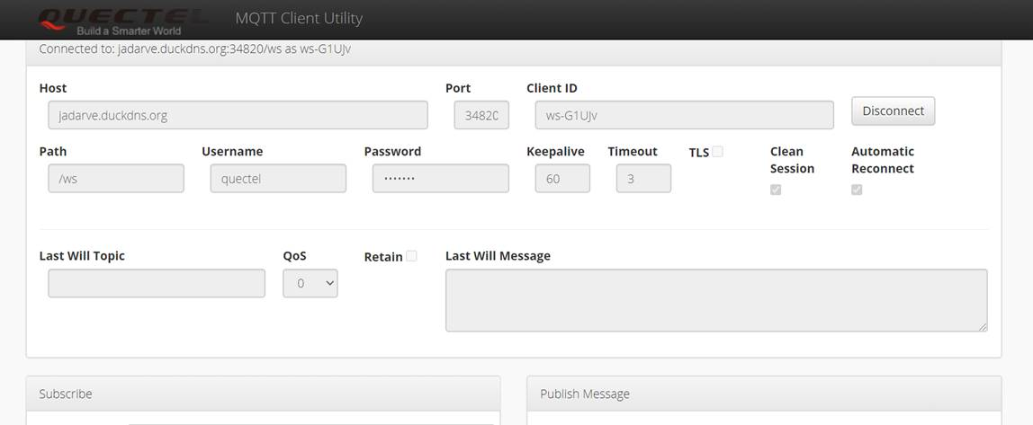

It is anonymous user, so you can user whatever user and password that you need.

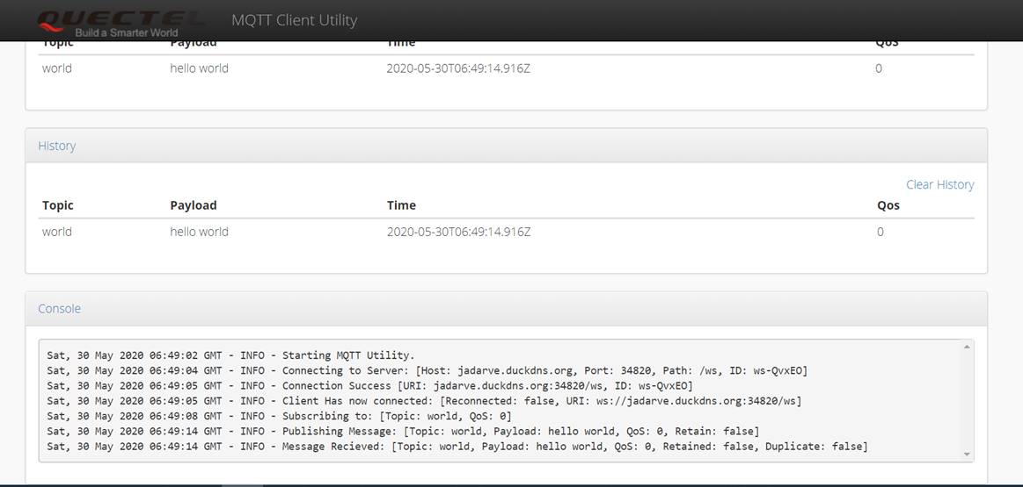

In addition to that you can use to test also broker from customers, for instance for testing using some examples

test.mosquitto.org Port 8081

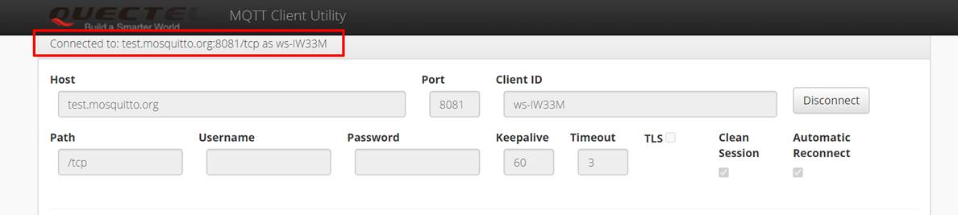

Connections are done based on webservices.

I hope it would be useful for you too with your testing.

Best regards and have a nice weekend,

Pepe